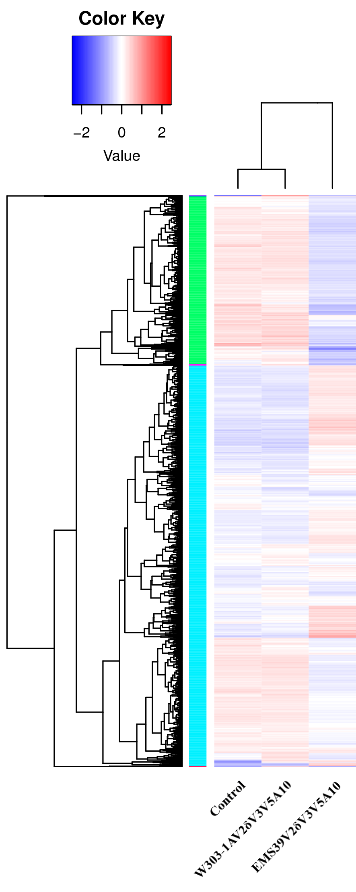
Fig. S1

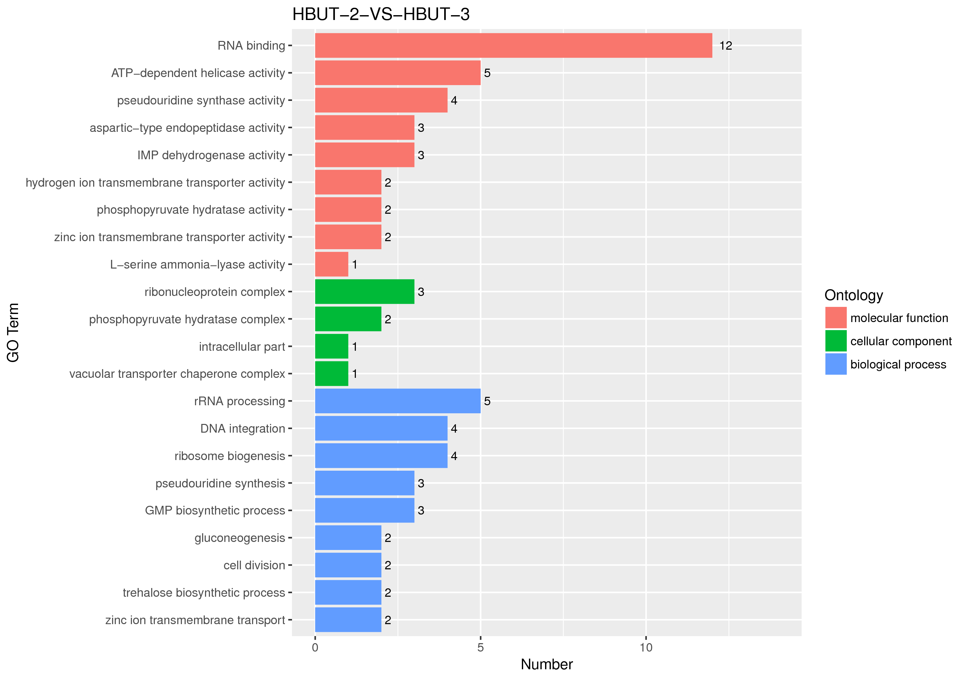
Fig. S2 Gene Ontology (GO) analysis

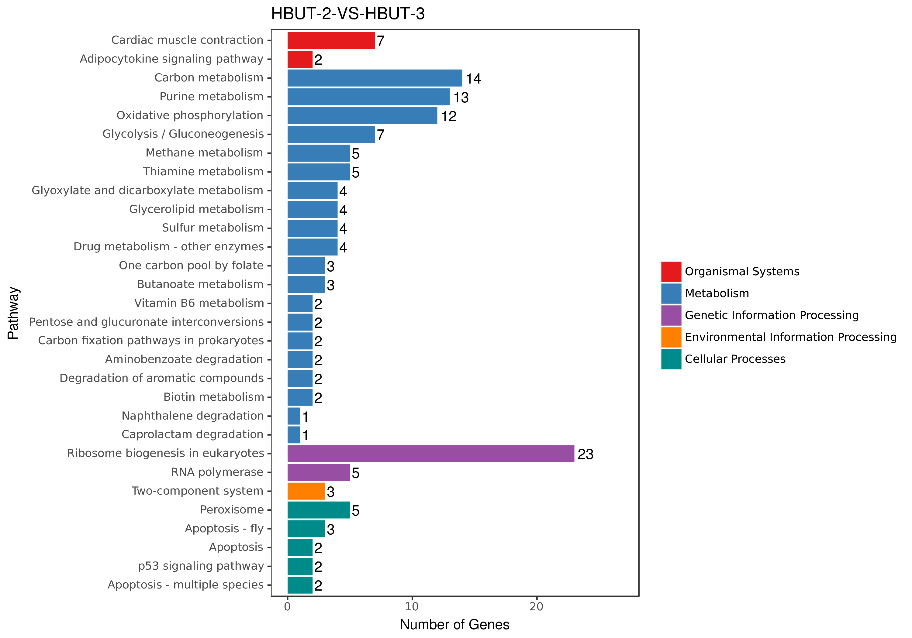
Fig.S3 KEGG enrichment analysis

